**ST. XAVIER’S COLLEGE**

**(Affiliated to Tribhuvan University)**

**Maitighar, Kathmandu**



**SIMULATION AND MODELING LAB REPORT #06**

**SUBMITTED BY:**

Pradeep Dahal

017BSCIT029

3rd year/ 5th Sem

|  |  |
| --- | --- |
|  | Signature |
| Mr. Ganesh Yogi  (Lecturer) |  |
| Department of Computer Science | |

**SUBMITTED TO:**

**LAB 6.1**

**TITLE: TO Find area under the curve using Monte Carlo Simulation of the curve Y= X2 .**

For Monte Carlo, simply define a rectangle that encompasses your function between the specified limits. Then generate uniform random pairs of numbers and scale them to fit as a point inside that rectangle. Count the number of points under the curve and divide that by the total number of points, multiply that ratio by the area of the rectangle, and the result will be the Monte Carlo estimate of the area under the curve.

For the calculus answer, simply integrate the function and apply the limits (value of the integral at the upper limit minus value of the integral at the lower limit).

**Result:**

**Range for x and y:**



**Value of n and N:**



**Random values:**

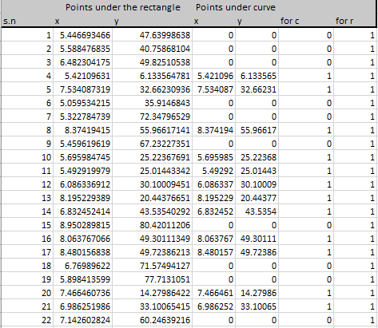

**Points under rectangle:**

For x, the formula in the excel sheet is given by:

=$B$2+ (($C$2 - $B$2) * RAND())

*(a + (b – a)*rand( ))*

For y, the formula in the excel sheet is given by:

=$B$3+ ((-$B$3 - $C$3) * RAND())

*(0 + (b – a)*rand( ))*

**Points under curve:**

For x, the formula in the excel sheet is given by:

=IF (C6<B6*B6,B6,0) ***//If y <= x2 , put value of X, otherwise 0***

For y, the formula in the excel sheet is given by:

= IF (C6<B6*B6,C6,0) ***//If y <= x2, put value of Y, otherwise 0***

**Value area by Monte-Carlo:**

= G2*C3*(C2-B2)

=199.908

**Value actual area:**

= ((C2*C2)/3)-((B2*B2)/3)

=201.333



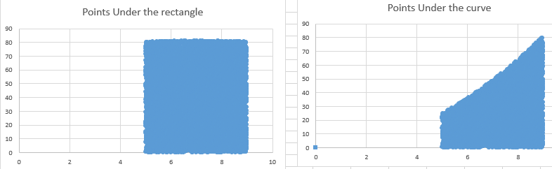

**Conclusion:**

Hence, the area under the curve was simulated using Monte Carlo method through MS-EXCEL.

# **LAB 6.2**

# **TITLE: TO FIND THE AREA OF THE CURVE X2=Y.**

**Theory:**

For Monte Carlo, simply define a rectangle that encompasses your function between the specified limits. Then generate uniform random pairs of numbers and scale them to fit as a point inside that rectangle. Count the number of points under the curve and divide that by the total number of points, multiply that ratio by the area of the rectangle, and the result will be the Monte Carlo estimate of the area under the curve.

For the calculus answer, simply integrate the function and apply the limits (value of the integral at the upper limit minus value of the integral at the lower limit).

**Result:**

**Range for x and y:**



**Value of n and N:**



**Random values:**

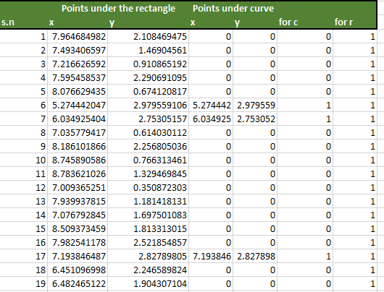

**Points under rectangle:**

For x, the formula in the excel sheet is given by:

=$B$2+ (($C$2 - $B$2) * RAND())

*(a + (b – a)*rand( ))*

For y, the formula in the excel sheet is given by:

=$B$3+ ((-$B$3 - $C$3) * RAND())

*(0 + (b – a)*rand( ))*

**Points under curve:**

For x, the formula in the excel sheet is given by:

=IF (B6 < C6*C6 B6, 0) ***//If x <= y2, put value of X, otherwise 0***

For y, the formula in the excel sheet is given by:

= IF (B6 < C6*C6, C6, 0) ***//If x <= y2, put value of Y, otherwise 0***

**Value area by Monte-Carlo:**

= G2*C3*(C2-B2)

= 1.542

**Value actual area:**

= ((C2^3)/3)-((B2^3)/3)

= 9



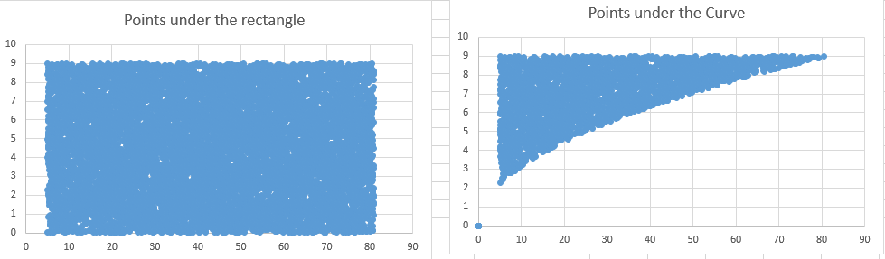

**Conclusion:**

Hence, the area under the curve was simulated using Monte Carlo method through MS-EXCEL.